*The Crystal Ball*

a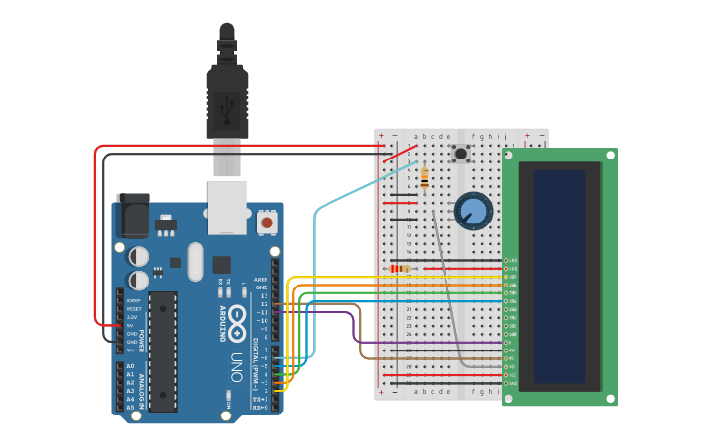



**Amethyst Lowe**

The University of Mississippi

Department of Mechanical Engineering

ME 537 Fundamentals of Mechatronics

Crystal Ball Project

3 December 2021

**Summary:**

In this project, we learned to use a Liquid Crystal Display, known better by its abbreviation to LCD. Although the LCD is connected to various signals as it receives different types of information, there is already an available Liquid Crystal Library which makes it easier to configure and control the characters displayed on the screen without managing low-level basics of how the screen actually works. The screen has up to 16 pins, ranging from digital pins to power supplies (Vcc, Vss, LED+-, etc.). The R/W sets up if the panel should be used to write or to read. Pin number 6 warns when it is to receive an instruction. Pin number 3 sets the luminosity of the screen. The creative part of this project consisted in using the screen as a fortune teller. If we turn the breadboard upside down, the screen will randomly search between its answers and display it on the screen. The potentiometer regulates the luminosity. This project was intended to connect the LCD screen to the Arduino setup and based on the code, the screen would produce different outputs. Using the potentiometer to control the clarity of the output, the screen would show whatever message that was written. The setup included many wires to carry electrical energy from the bus line to the actual LCD screen to power up each screen cell. Specifically in this project, an array of strings was used to randomly select an output as the answer to a question that was asked to this “crystal ball.” Below in Figure 1 displays all the main components of this project.

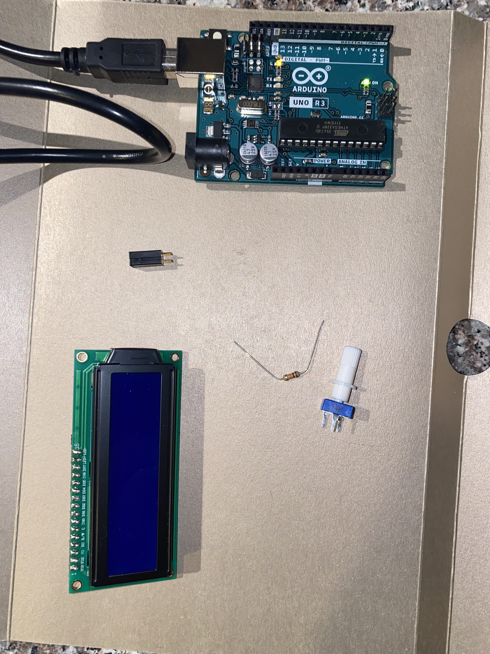

*Figure 1: Ingredients for this experiment*

**Introduction:**

The goal of this project is to perform a fortune teller using the Arduino and connection wires to generate random messages from the 8 different “clear” statement outputs. The potentiometer was used to control the transparency of the output and the LCD displayed the message written in the code. The setup included the Arduino, 2 resistors 10kΩ and 220Ω, many jumper wires to carry electrical energy from the bus line to the actual LCD screen to power up each screen cell, a potentiometer, and a tilt sensor as shown in. *Figure 2* and *3*. This project used many wires to randomly select one of the outputs of the code shown in *Figure 4* as the answer to a question that was asked to the crystal ball.

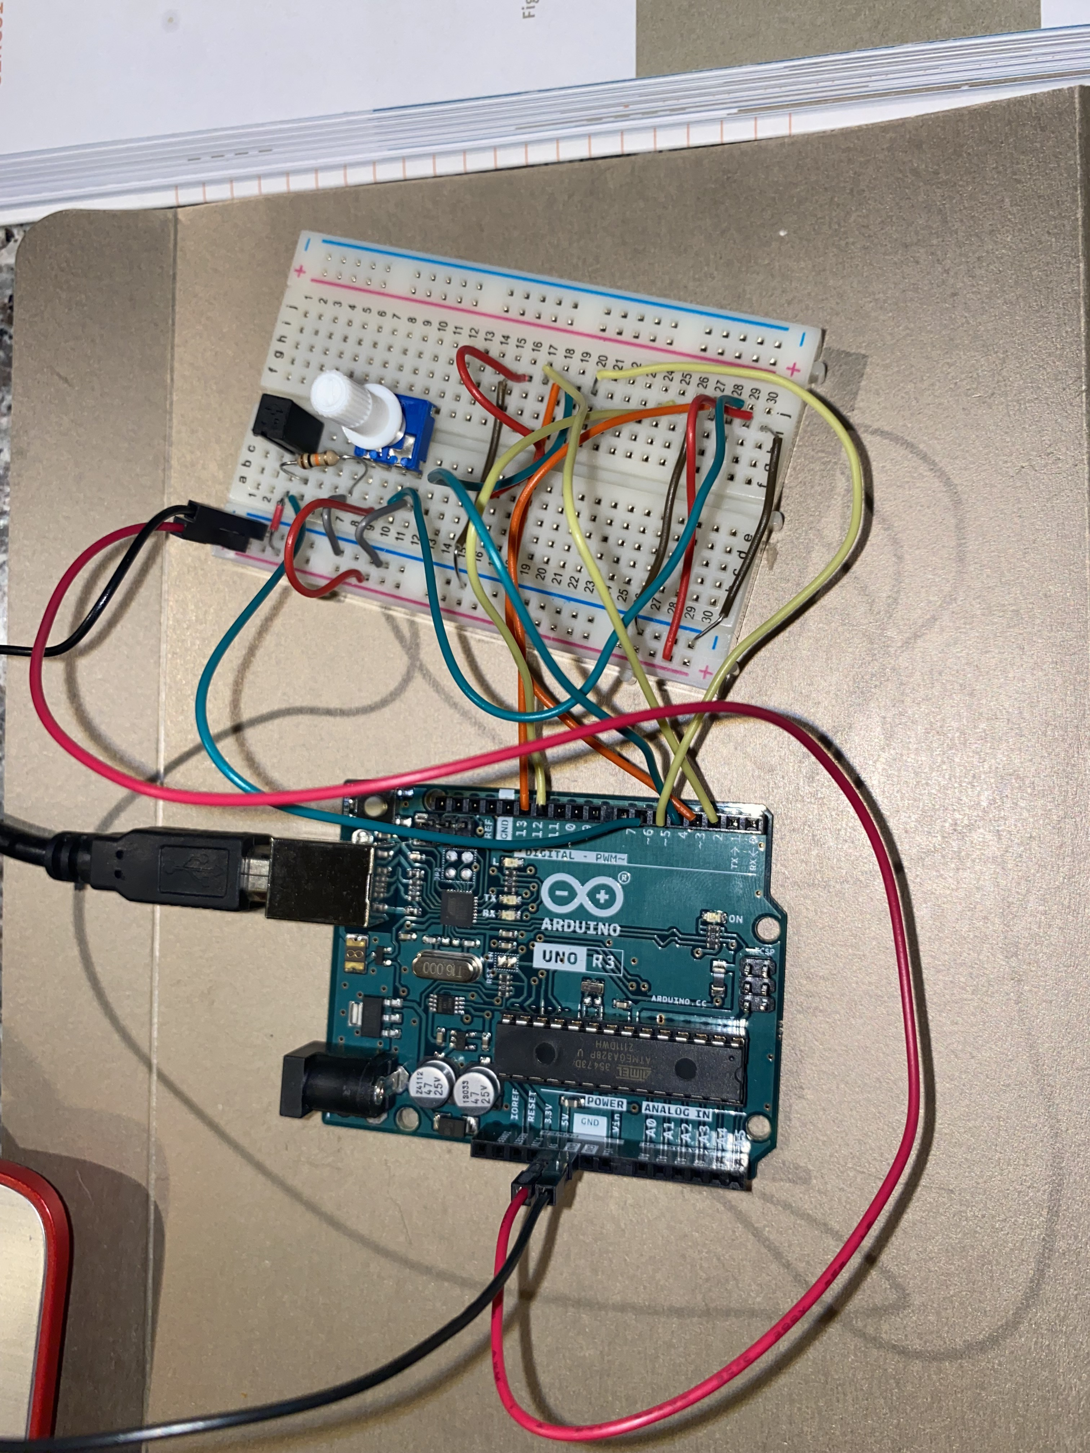

*Figure 2: Setup of the wires before LCD added*

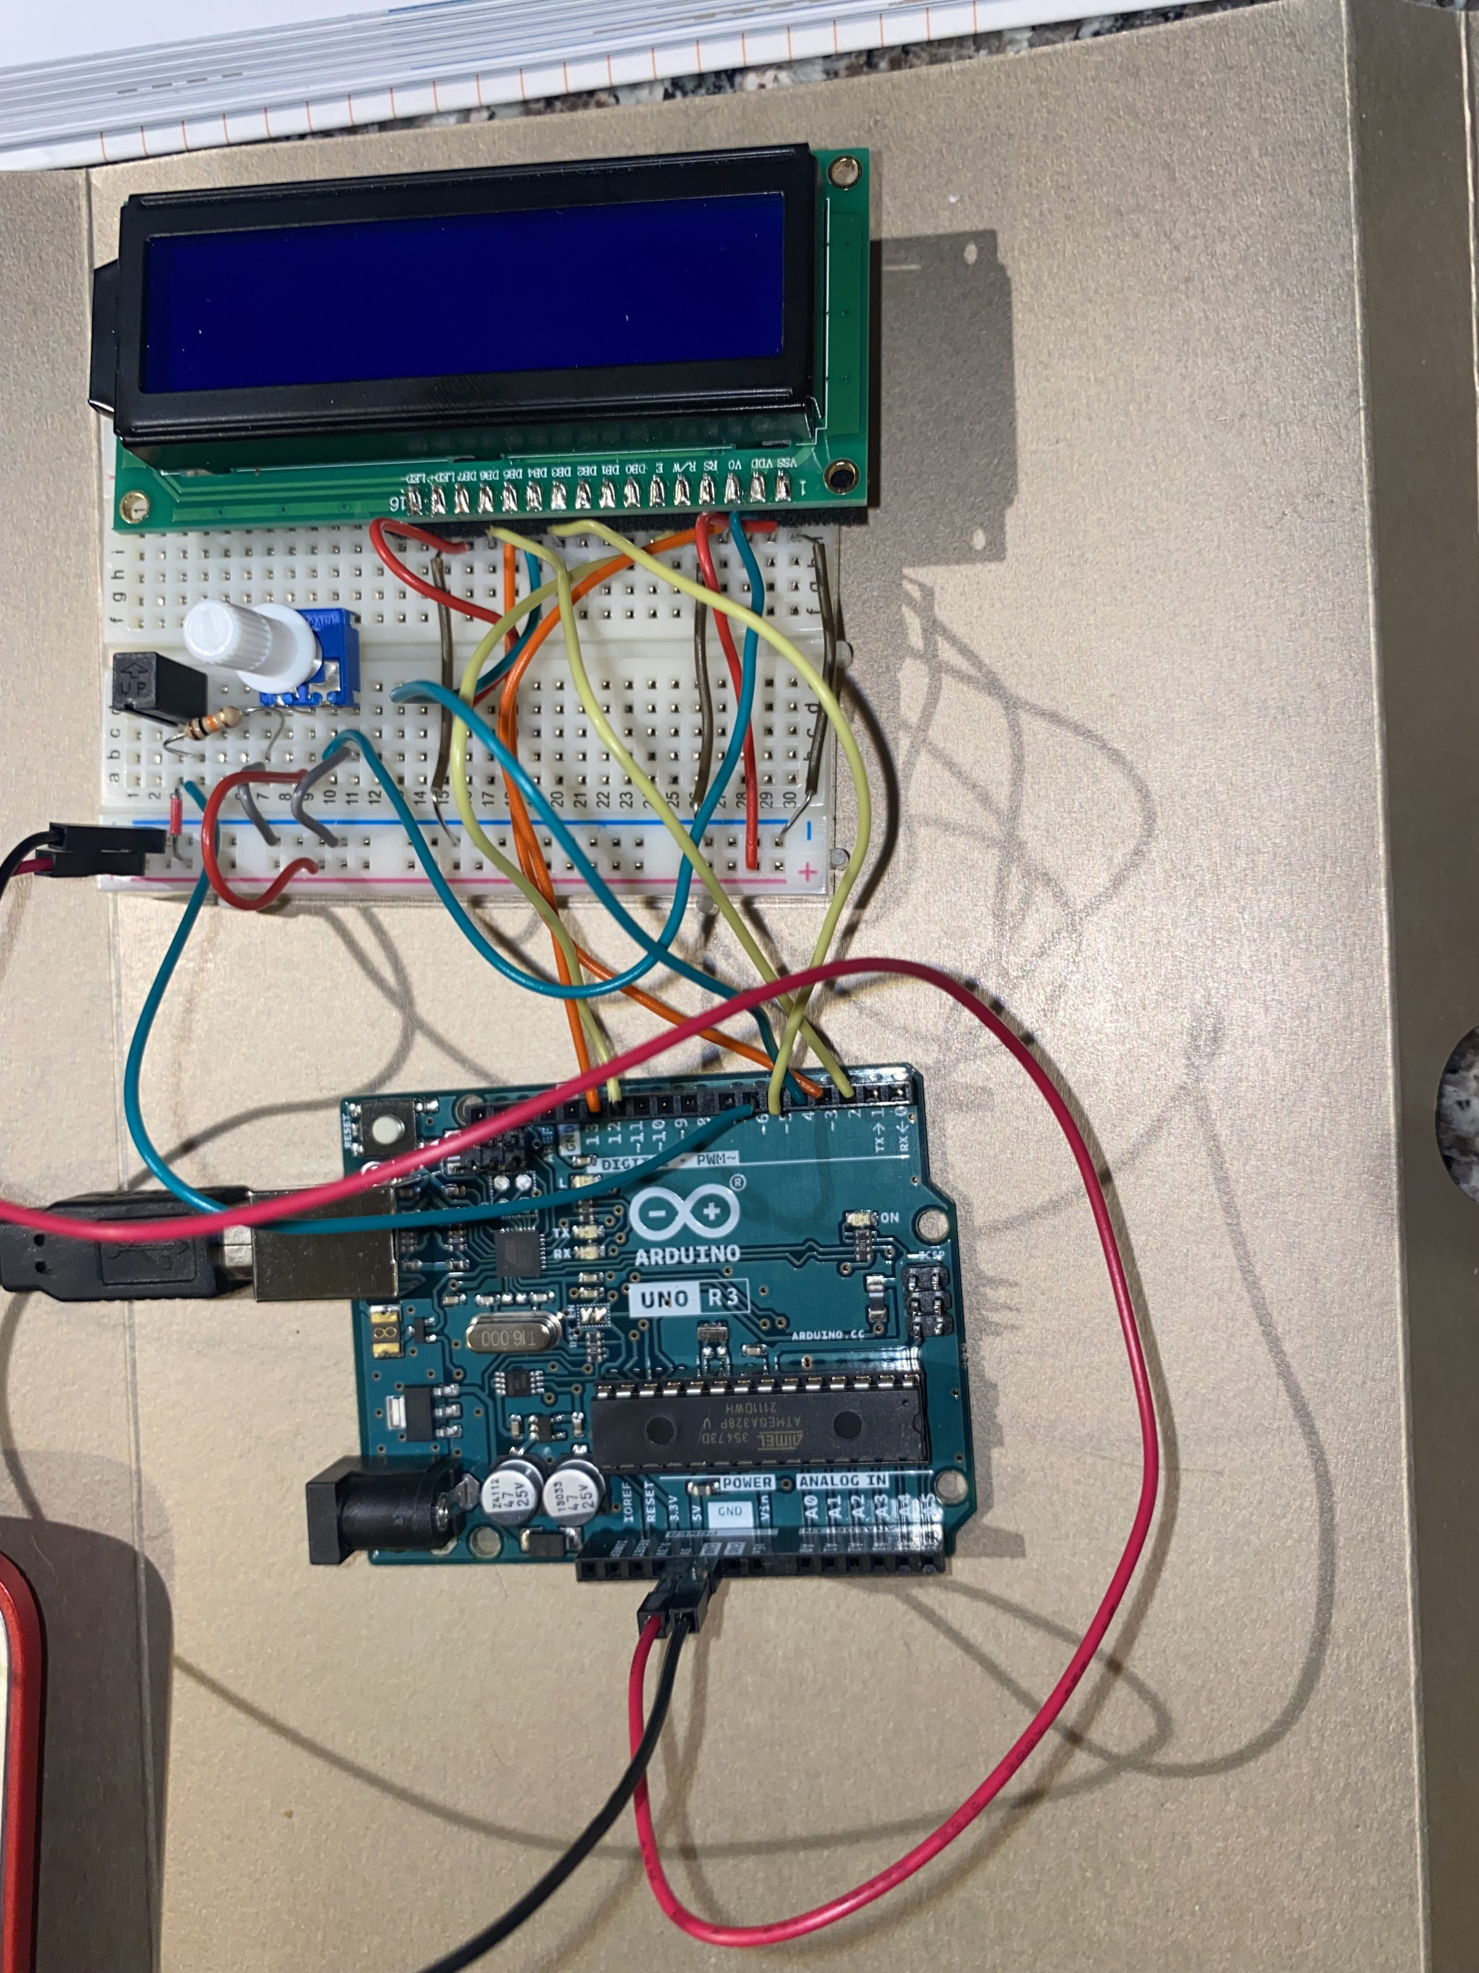

*Figure 3: Setup of the wires after LCD added*

**Design Specifications:**

This design was sampled from the Arduino project book in order to incorporate an understanding of the Mechatronics used throughout the semester. In *Figure 2, 3,* and *5* shows the completed circuit. This design resulted as a success, and I changed some of the clear statements to other statements of my own.

*The Code:*

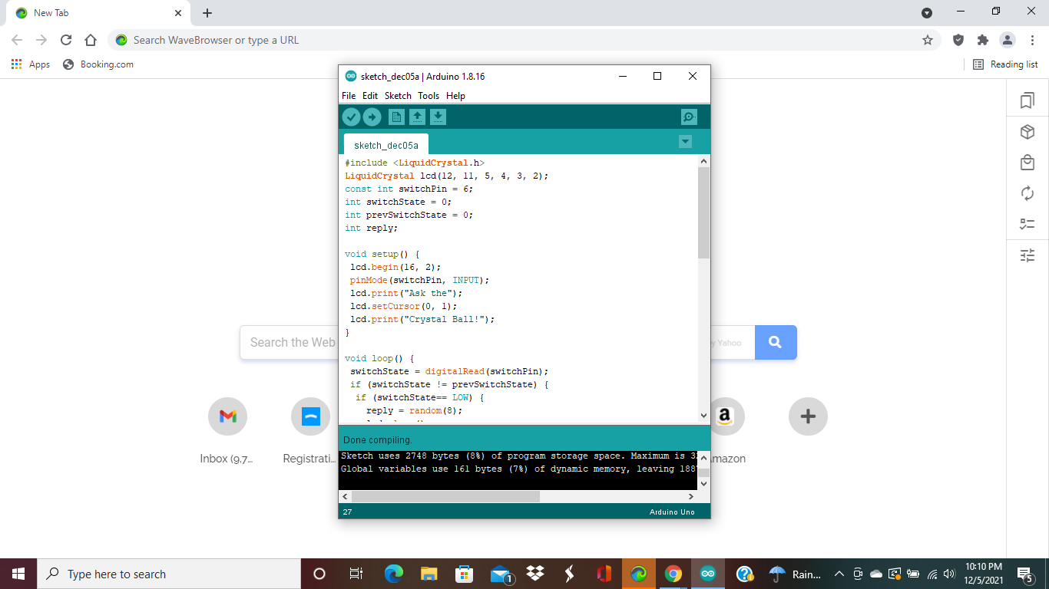

*Figure 4: The Code*

**Outcome:**

As seen below in Figure 5, the LCD screen displayed the code uploaded in order to use the crystal ball. The LCD was not bright enough initially, and I tweaked the potentiometer so that the words were not translucent. In the clear statements in the code. I changed them to say other statements for my crystal ball, but it had to be no greater than sixteen characters. There was also a problem with the 220Ω resistors being in the wrong column initially and nothing would show up. Once all the problems were fixed and I checked the wiring once more the LCD worked. Overall, this was a great project to do individually, and it was performed successfully.

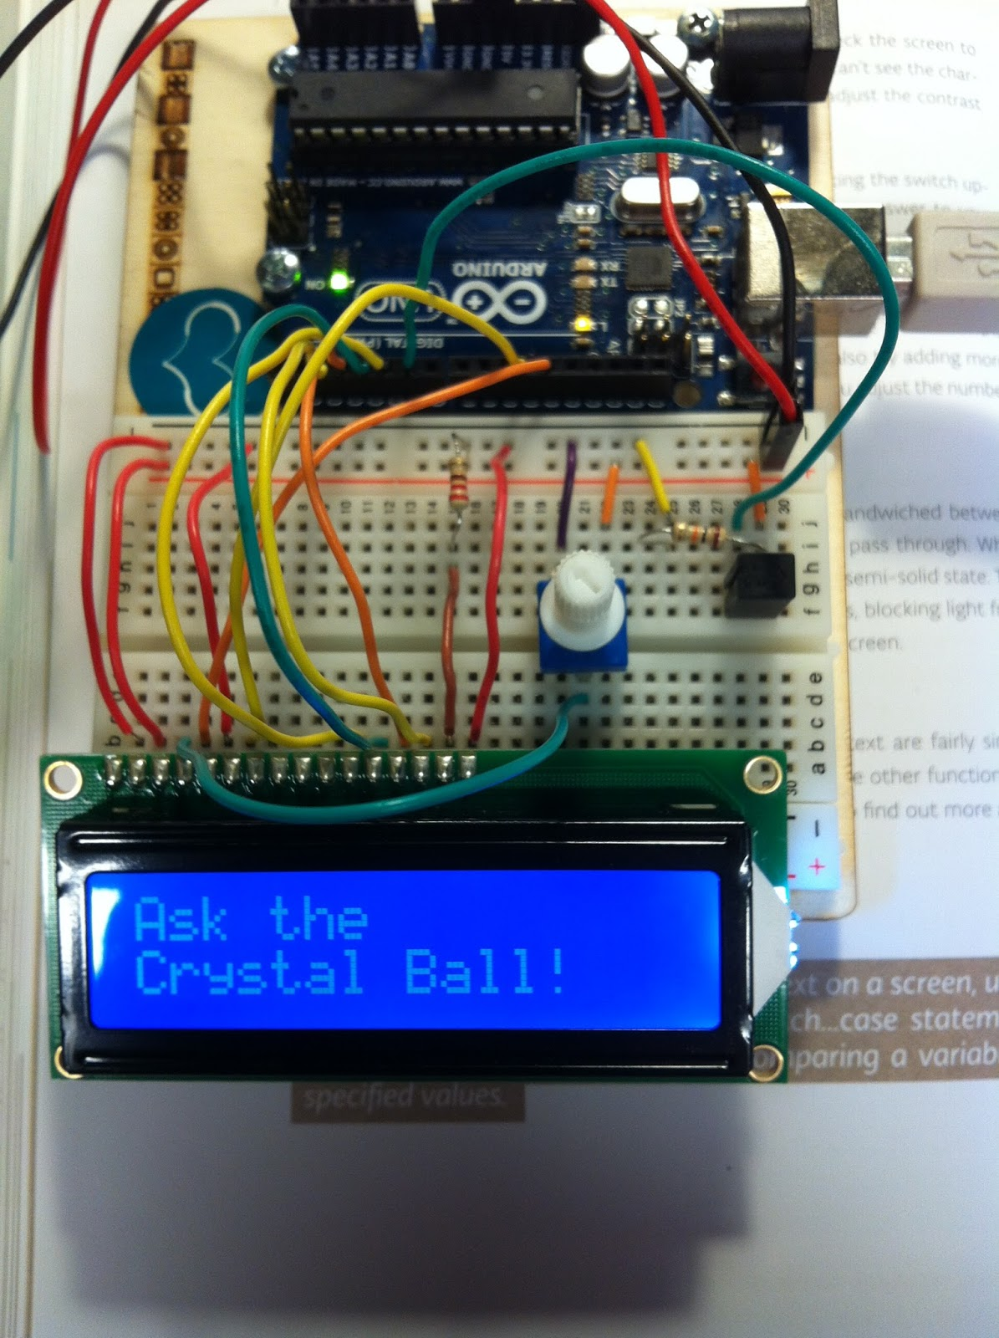

*Figure 5: LCD Crystal Ball*

**References:**

Rgto. (2018, October 4). *Arruino Uno Crystal Ball*. Arduino Forum. Retrieved December 6, 2021, from <https://forum.arduino.cc/t/arruino-uno-crystal-ball/549360>.

**Appendix:**

// include the library code:  
#include <LiquidCrystal.h>  
  
// initialize the library with the numbers of the interface pins  
LiquidCrystal lcd(12, 11, 5, 4, 3, 2);  
  
// set up a constant for the tilt switchPin  
const int switchPin = 6;  
  
// variable to hold the value of the switchPin  
int switchState = 0;  
  
// variable to hold previous value of the switchpin  
int prevSwitchState = 0;  
  
// a variable to choose which reply from the crystal ball  
int reply;  
  
void setup() {  
// set up the number of columns and rows on the LCD  
lcd.begin(16, 2);  
  
// set up the switch pin as an input  
pinMode(switchPin,INPUT);  
  
// Print a message to the LCD.  
lcd.print("Ask the");  
// set the cursor to column 0, line 1  
// line 1 is the second row, since counting begins with 0  
lcd.setCursor(0, 1);  
// print to the second line  
lcd.print("Crystal Ball!");  
}  
  
void loop() {  
// check the status of the switch  
switchState = digitalRead(switchPin);  
  
// compare the switchState to its previous state  
if (switchState != prevSwitchState) {  
// if the state has changed from HIGH to LOW  
// you know that the ball has been tilted from  
// one direction to the other  
if (switchState == LOW) {  
// randomly chose a reply  
reply = random(8);  
// clean up the screen before printing a new reply  
lcd.clear();  
// set the cursor to column 0, line 0  
lcd.setCursor(0, 0);  
// print some text  
lcd.print("the ball says:");  
// move the cursor to the second line  
lcd.setCursor(0, 1);  
  
// choose a saying to print baed on the value in reply  
switch(reply){  
case 0:  
lcd.print("Yes");  
break;  
  
case 1:  
lcd.print("Most likely");  
break;  
  
case 2:  
lcd.print("Certainly");  
break;  
  
case 3:  
lcd.print("Outlook good");  
break;  
  
case 4:  
lcd.print("Unsure");  
break;  
  
case 5:  
lcd.print("Ask again");  
break;  
  
case 6:  
lcd.print("Doubtful");  
break;  
  
case 7:  
lcd.print("No");  
break;  
}  
}  
}  
// save the current switch state as the last state  
prevSwitchState = switchState;  
}

*Bill of Materials:*

|  |  |
| --- | --- |
| **Material** | **Price (USD)** |
| Arduino Starter Kit | $80.00 USD |